7.13. Distribution Center Tab
The Distribution center tab is used to plan your inventory for the supply chain represented by a two-echelon model. The goal of this tab is to generate an ordering plan for distribution centers based on the demand from the lower echelon and DCs' replenishment parameters. The ordering plan for the other locations of the two-echelon model is on the Inventory planning tab.
Depending on the Streamline configuration, an ordering plan may include any combination of the following:
- a purchase plan showing replenishments from your suppliers;
- a material requirements plan and a production plan.
A planning item in an ordering plan belongs to one of three mentioned plans. In addition to the ordering plan, this tab provides a bunch of other important outcomes, including expected stockouts and overstocks.
Distribution center tab contains a set of tabs or reports, a toolbar and a table under each tab (see figure below).
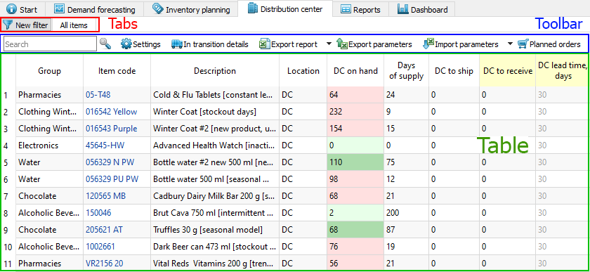
By default, the tab area includes only one report All items. Just as the Inventory planning tab, the Distribution center tab allows using filters for creating custom reports, displaying items that satisfy the given criteria. The New filter button opens the Filter dialog that is used to specify the filtering criteria for the new custom report. As soon as you configure the filter, Streamline creates a new report based on it and adds it to the set of tabs as a newly created tab.

Capabilities of reports
The All items report, as well as any other custom report, is customizable. The table below shows the customizations and the scope they are applied to.
Customization | Scope
Show/hide a particular set of columns of the report using the Settings. | All of your reports at once.
Recalculate the report based on the given replenishment parameters. | All of your reports at once.
Display the necessary set of planning items by creating a new report using filters or editing the filter of the current report. | Current report
Sort the report by any column or a set of columns. | Current report
In addition, you can export any report to an Excel file.
As you see, reports in this tab are interactive, since allowing manual change of the parameters, and are recalculated after the change. There are several ways to change replenishment parameters. The easiest one is modifying them right in the report by editing the columns having a yellow background.
 | As soon as any of the parameters has been changed, Streamline automatically recalculates the outcomes of the Distribution center tab. Hence, Distribution center tab always shows you the Ordering plan and the Projected inventory levels at the current state of the parameters.

Toolbar
- Search toolbar is used to search for a particular phrase in the Item code and Description columns of the currently active report. The search is not case-sensitive and searches for the substring in a string. To start the search or find the next occurrence, press Enter, or F3, or click on the search icon.
- Settings button opens the Distribution center settings which are applied to all of the reports of this tab.
- Edit filter button opens the filter dialog for the currently selected report where you can edit filtering criteria.
- In transition details button opens the In transition details dialog.
- Export table button command exports the currently active report to an Excel file. Next to the button is a little black triangle that shows you additional exporting options:
- Export to XLSX command exports the currently active report to an Excel file as well as the Export table button.
- Export to database executes the Export inventory forecast and Export inventory planning table exporting queries configured in the Database connection. This option is active if the project is connected to a database through the Database connection.
- Export parameters exports DCs' replenishment parameters into the on-the-fly created Excel file where they can be edited.
- Import parameters loads the Excel file created using the Export parameters button. You can optionally choose any other Excel file to load. To do this:

1. Click on a little triangle near the button.
2. Select the Choose file… command.
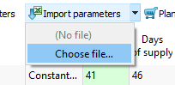
3. Choose the file and click OK.
- Planned orders button opens the Planned orders preview dialog.
- Total order value shows the total value of the current order in the supplier's currency. In other words, it is the sum of the Current order, Value column.

Table
Each report in the Distribution center tab contains a table. Columns of these tables are the same for each of them. Table columns can be divided into the following categories:
- Inventory information -- descriptive information about the planning item.
- Replenishment parameters -- the inputs of the inventory replenishment process. Some of them are constraints used in the optimization.
- Outcomes -- an ordering plan and other inventory characteristics that are calculated based on the forecasts and replenishment parameters.

Description
The table below gives a description of all of the columns.
Column | Description
Inventory information
<Item category> | Streamline shows the column configured as item category in the table. The name, imported for this column, is displayed in the column header.
<Location category> | Streamline shows the column configured as location category in the table. The name, imported for this column, is indicated in the column header.
<Item info field> | Streamline shows the chacteristic of the item imported through the Info field data type in the table. The name, imported for this characteristic, is shown in the column header.
Item code | An identifier of the item also known as SKU.
Description | This column shows the description of the Item code.
Location | It shows the name of the distribution center where the Item code is stored.
Item type | It indicates the type of the item. It is shown if bill of materials was imported. There are three types of items, Material, Intermediate and Finished item. A blank cell in this column refers to a regular item; it is not involved in any manufacturing process.
Supplier | Shows the code of the supplier that is used to replenish the planning item.
Purchase price | It is the price you pay the supplier for the item in the supplier's currency. This column is shown if the item purchase price was imported.
Note | Shows the annotation for the planning item. Notes can be created using the context menu of the table or at the Demand forecasting tab.
Replenishment parameters
DC on hand | The amount of the Item code that is currently in stock at the Location.
DC to ship | Shows the total quantity on open sales orders and backorders. If open sales orders and backorders are imported separately from the inventory information, this column shows a little triangle in the corner of the cell. If you hover over it, Streamline shows a popup containing a list of pending shipments.
DC to receive | Shows the total amount on open purchase and manufacturing orders. If those orders are imported separately from the inventory information, this column shows a little triangle in the corner of the cell. If you hover over it, Streamline shows a popup containing a list of pending arrivals.
DC lead time | Shows the interval of time between purchase order placement and its receipt. Streamline shows dashes for Finished and Intermediate item, meaning that the lead time for them can't be given. By default, it eqauls to zero.
DC order cycle | Shows how often the item is ordered from the supplier. Order cycle can be set in months or days, or attached to the Lead time period.
DC service level | It is the percentage of the time (in the long run) that the item is available in stock. It should be given if a DC sells items.
DC safety stock periods | Shows the number of future periods which demand is used as the DC safety stock.
Replenishment constraints
DC min lot | It is the minimum quantity of the planning item that you can order from your supplier.
DC max lot | It is the maximum amount of the planning item that you can order from your supplier.
DC rounding | It is a constraint that rounds the Net order amount up to the given quantity. It allows Streamline to take into account how many items come packed in a carton, allowing the application to suggest exactly the right amount of the item to order.
Display qty | Shows the minimum number of units a DC shelf has to display. This parameter should be given if the DC sells items. It is used to increase DC safety stock. You can control how this amount is account for in the calulation.
DC shelf life | It is the desired time the item can be in stock. Streamline converts this time period into a shelf life quantity. And this amount is used as a maximal limitation on the Net order quantity when the current order quantity is calculated. A cell in this column has a red background if the Net order quantity exceeds the shelf life quantity.
DC shelf life exceeding | Shows the average percentage of the current order quantity that we might have to: send to a clearance sale, return to the supplier and so on. If you just discard the expired product, the percentage should be very small. If you recycle them (e.g. roast the meat or make a clearance sale), the numbers may be larger.
Outcomes
Days of supply | Shows how many days of the future demand, starting from the project date, the current On hand (including orders to ship) can cover. You can switch this indicator between days or months in the Settings.
DC safety stock | Indicates the DC safety stock for the planning item. If a DC sells a planning item in addition to distributing it, this indicates the sum of safety stocks -- the Safety stock and the DC safety stock.
Safety stock debt | This section indicates three characteristics of safety stock: 1) safety stock debt received from the lower echelon; 2) safety stock debt accumulated at the current echelon; and the 3) safety stock debt calculated at the current echelon and then passed to the upper echelon.
Safety stock debt | Received | The total of the safety stock debts passed from the lower echelon.
Safety stock debt | Accumulated | The accumulated safety stock debt that is calculated at the current echelon.
Safety stock debt | Passed | The safety stock debt passed to the upper echelon.
Gross margin | Shows the gross profit margin of the planning item. It is calculated if the planning item is sold in DC.
Turn-earn index | Indicates the item gross margin accumulated over the last 12 months. It is calculated if the planning item is sold in DC.
Current order | This section displays information on the current order.
Current order | Qty | It is the recommended quantity to order currently.
Current order | Net order | It is the current order quantity before application of constraints.
Current order | Excess order | Shows the excess part of the сurrent order quantity that is gotten due to the application of the constraints. In other words:  Excess order = Qty - Net order
Current order | Value | Shows the value of the current order line in the supplier's currency. It is calculated based on the given item purchase price.
Current order | Margin | This column shows the gross profit margin calculated for the current order. The sellout_time equals to the Days of supply of the current order when it is calculated. This column is shown if the Annual interest rate is set in the Project settings.
Current order | Days of supply | Shows how many days of the future demand, starting from the Delivery date, the current order quantity can cover.
Current order | Order type | Indicates the order type the current order line blongs to. There can be two types of orders in this column, Purhcase and Manufacturing. Streamline automatically determines it based on the Item type column.
Current order | Source from | Displays the source from where the planning item is currently ordered. This column shows the supplier code, if Supplier code data type is imported.
Current order | Delivery date | Shows the promised date on which the planning item is to be delivered. Its calculated as:  Delivery date = Today date + DC Lead time,  where Today date is the current date set on your machine.
Next order date | It indicates the date the next order should be placed by. This column is automatically calculated for the exported order lines as you click the Create button in the Planned orders preview dialog. In this case, the date is calculated as:  Next order date = Today date + Order cycle,  where Today date is the current date set on your machine.  Streamline also populates this column for the items to receive that have Sendout date given. In this case, the formula is:  Next order date = Sendout date + Order cycle.
DC reorder point | Displays the inventory level at which a purchase order should be placed. It is the sum of the DC lead time demand and the DC safety stock. This column is shown if the Min/max replenishment strategy is set for DCs in the Settings.
DC max inventory | It is the maximum inventory level for the item in the current period. This column is shown if the Min/max replenishment strategy is applied.
DC stockout | It is the maximal expected inventory shortage during the DC lead time period.
DC overstock | Shows the expected inventory level at the end of the DC lead time plus DC order cycle period.
Write-offs | Indicates the total of the projected write-offs over the forecast horizon.
DC ordering plan | This section contains ordering recommendations for the whole forecast horizon. The current order recommendations are shown in the first column of this section. The values in the plan indicate the quantities that should be ordered in the corresponding periods. After you export the current order recommendations, Streamline shows the date to place the next order by in the Next order date column of the table. This section is hidden by default; you can show it by enabling the option Show entire ordering plan in the Settings.
DC demand forecast | This section shows the DC demand forecast passed from the lower echelon for every period within the forecast horizon. If a DC sells and distributes an item, it shows the sum of the demand forecast based on the sales and the demand forecast based on the distribution.
Projected inventory levels | This section contains the expected inventory levels at the end of each period within the forecast horizon. This section is hidden by default; you can show it by enabling the option with the same name in the Settings.
Constraints Min lot, Max lot, and Rounding can't be given for manufacturing items. Streamline shows dashes in these columns for them. Empty cells or zero values in the Min lot, Max lot, and Rounding columns mean that no constraints are applied in the optimization.
 | DC safety stock can be used as input, in case you need to set it manually. Data entered into Streamline manually has a higher priority over the defaults and outcomes.

Color-coding
The table in the All items report has a color-coding helping you recognize red-flag items. To describe the color-coding, let's introduce the following notation:
- D(LT) -- expected demand for the DC lead time.
- D(LT+OC) -- expected demand for the DC lead time plus DC order cycle period.
- ToReceive(LT+OC) -- the total item quantity to be received during the DC lead time plus DC order cycle period.
- ToShip(LT+OC) -- the total item quantity to be shipped during DC lead time plus DC order cycle period.
Below we describe the meaning of colors used in the colored columns or sections of the table.

On hand
Color | Meaning
Pink | The quantity is insufficient to cover D(LT).
Light-green | The quantity is enough to satisfy D(LT).
Green | The quantity is enough to satisfy D(LT+OC).

Stockout and Overstock
Color | Meaning
Pink | Indicates stockouts in the Stockout column.
Green | Hightlights overstocks in the Overstock column.

Demand forecast and Projected inventory levels
Color | Meaning
Pink | Designates periods with stockout.
Light-green | Specifies periods in which demand will be fully covered with (On hand + ToReceive(LT+OC) - ToShip(LT+OC)) quantity.

Context menu
The All items report (or any other custom report) has a context menu that includes the most commonly used operations applied to the currently selected planning item in the table.
To open the context menu, right-click on the planning item (see figure below).
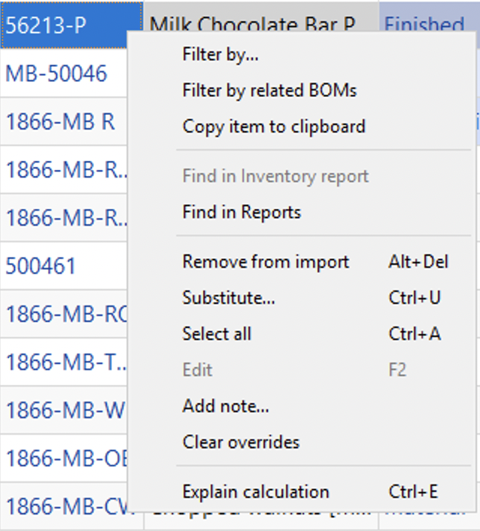
Below we give a description of the commands.
- Filter by… will open a new filter dialog with automatically applied criterias so you can quickly sort using these specifications.
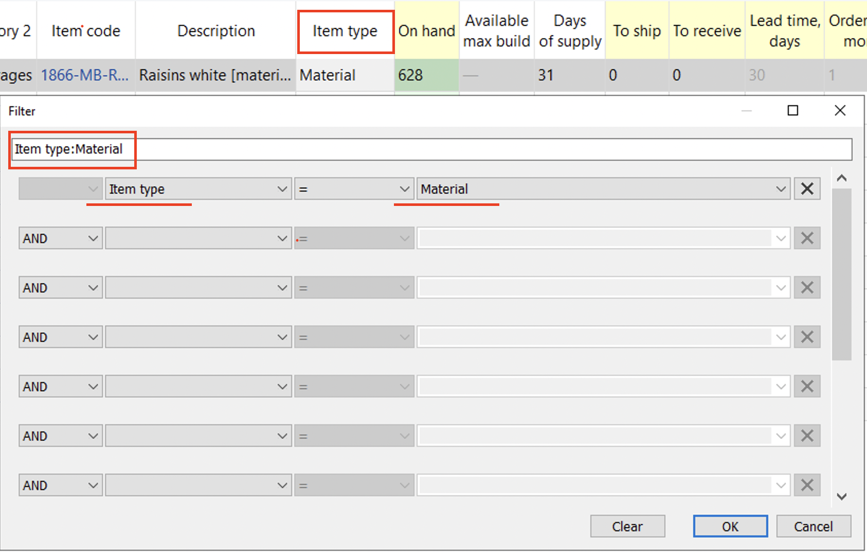
- Filter by related BOMs will open a new filter dialog where you can separate items related to the selected BOM.
- Copy item to clipboard copies the item code of the selected planning item to the clipboard.
- Find in Reports will take you to the selected item in Reports tab.
- Remove from import... bans the selected item code (not planning item) from import.
- Substitute merges the selected planning item with the planning item which code is provided in the appeared window on a channel basis (see figure below). If the provided item code exists in the project, this operation removes the item code of the selected planning item from the project, otherwise, it renames it.
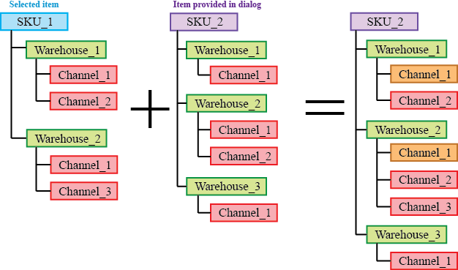
Orange in the figure above indicates the channels with merged histories.
- Select all selects all items in the report.
- Edit switches the selected cell into editing mode allowing you to enter a new value for the parameter. This command is only active for the cells in editable columns (the headers shown in yellow). It can be used for a mass changing of a certain replenishment parameter for a given set of planning items.
- Add note opens the Edit note dialog (see figure below) where you can add, remove, or edit the note for the selected planning item.
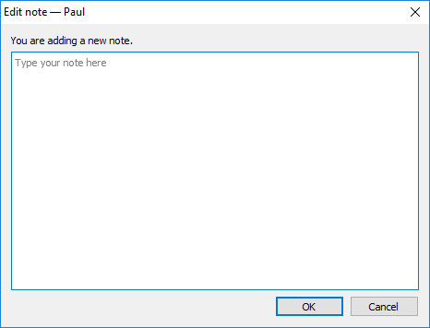
- Clear overrides will revert back all the changes that have been made to the selected item.
- Explain calculations shows the Explain inventory calculation dialog for the selected item.

Next: Program Settings
Download PDF
Tracedump:
newBaseSize: 16pt
newBaseSizeInPt: 16

